**Formatting Text, Creating Text, Editing Text, Polylines, revision cloud and Parametric Constraints**

**Working with Text**

Like most things in AutoCAD, there is more than one way to do it. Creating Text is no exception. Below are the common commands for working with text.

|  |  |  |  |  |
| --- | --- | --- | --- | --- |
| **Command** | **Keystroke** | **Icon** | **Location** | **Result** |
| Text Style | STYLE / ST | Text Style Icon | Home > Annotation > Text Style | Opens the Text Style Dialog |
| Single Line Text | **DTEXT / DT / TEXT** | DText Icon | Home > Annotation > Single Line | Creates a single line of text |
| Multiline Text | **MTEXT / T / MT** | MText Icon | Home > Annotation > Multiline Text | Creates formatable multiline, paragraph text |
| Edit Text | **DDEDIT / ED** (or double-click) | No Icon | None | Edits and formats text - edits attributes |
| Spell Check | **SPELL** | Spell Check Icon | Annotate > Text > Check Spelling | Checks for spelling errors in Text, Attributes and Xrefs |
| Text along an arc | ARCTEXT | ArcText Icon | Express > Text > Arc-Aligned Text | Aligns test along a selected arc |

Creating text in AutoCAD is easy. You may have already done this in the first level of tutorials, but this lesson will go into more detail and explore more options.

**Formatting Text Styles**

Most template drawings will have your text styles defined. Generally you won't change these. Occasionally you may need to create a new text style (definition of the way the text will look). For example, the font that is used is defined by the Text Style.

To format text in AutoCAD, you have to create a new text style for each different font and style of text.

By default in the acad.dwt file, AutoCAD loads the **txt.shx** font because it is simple to display on the screen. Unfortunately, it is a very basic and 'ugly' font. Here is an example of the default TXT font compared to the 'standard' ROMANS font. Look at the O's in particular. The TXT font has no curves.



It is easy to load in a new style for all of your text. Here's how:

Use your pull-down menus Format > Text, or type **ST**, and this dialog box appears.

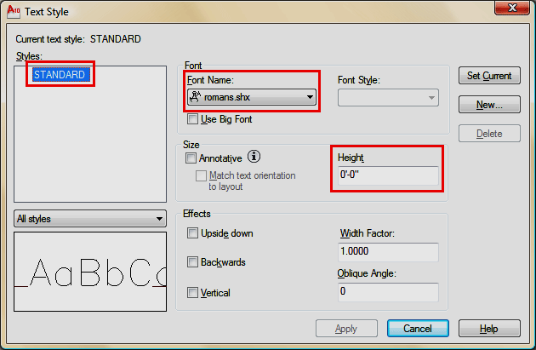

Select the **New...** Button and type in a name for your new text style.

Click on the **Font Name** edit box and select "romans.shx" as your new text style. This style will be used for all text and dimensioning in the next assignments. This is a common, clean font that AutoCAD can display quickly on the screen. No other adjustments are needed. Optionally you can set the width factor to a .8 - this allows you to fit text in narrower spaces at an 80% width.

**IMPORTANT:** Do **NOT** change the Height in this dialog box unless you really know why you are doing it. If you set a height here, AutoCAD will not be able to scale if for uses such as dimensioning, in other words, it is fixed at the height you set.

Once you get into more complex drawings, you will need more than one text style (if they aren't in the template). One for notes, one for tables, one for the table header, two or three for the title block - I think you get the picture.

If you need more than one text style, click on the new button, type in a new name and press OK.

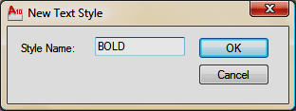

Now the Text Style dialog box (as shown above) will have the new name in the Style Name field. Select **RomanD.shx** for this new style.

Now when you add text to your drawing, you have 2 choices. Watch the command line to know when to change to another style.

**Adding Text to a drawing**

Of course, there a few ways of entering text in AutoCAD. For simple one line text, use the the TEXT command. There's a few parameters needed to add text, but if you follow the command line, it's quite easy.

Command: TEXT

Current text style: "Romans" Text height: 0'-6" Annotative: No  
Specify start point of text or [Justify/Style]: <PICK>  
Specify height <0'-6">: 12

Specify rotation angle of text <0.000>: <ENTER>

TYPE YOUR TEXT and press <ENTER><ENTER>

You should now have a line of text in your drawing. Start the command again and when prompted for Justify/Style, type S and enter the name of the second text style you created.

Once you have used the two different styles, it should look something like this:

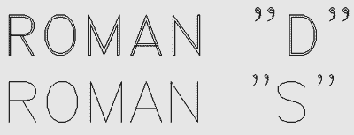

In later versions of AutoCAD, there is an easy way to change existing text to a new style. First, select the text, then go up to the Text Style Menu (Home > Annotation > Text Style) and select the style you want from the droplist (below) and the text will change automatically.

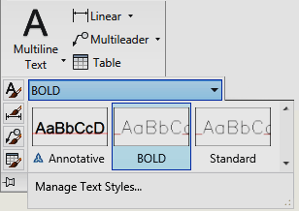

Professional looking and clear text is essential in any CAD drawing. Practice with different styles until you are comfortable with these concepts.

**Multiline Text**

Often you will want to enter a block of text, maybe a paragraph explaining a problem. In this case, MTEXT is what you need. Mtext allows you to format your text much like a word processor.

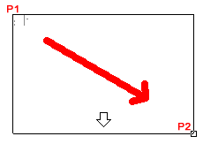Start the Multiline Text command, and pick a spot in the drawing. Drag the cursor over to create a 'rectangle' to represent the area you want your text in, and pick the other corner. As soon as you pick the second point (P2), the full Multiline text editor will appear. Type your text, and press OK when done.

All of a sudden, AutoCAD turns into a word processor.

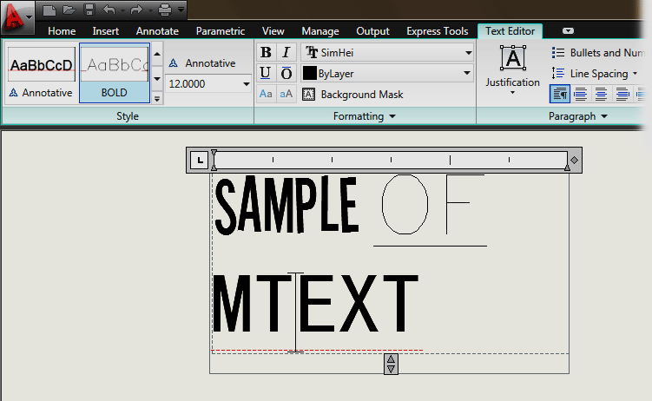

You now have a huge amount of options for editing your text. You can change the font, size, color - all without having to create a new text style.

If you use a True Type font for your text style, you have more options for formatting (just don't get carried away). Imagine a large drawing where everyone decides their own way of showing text.

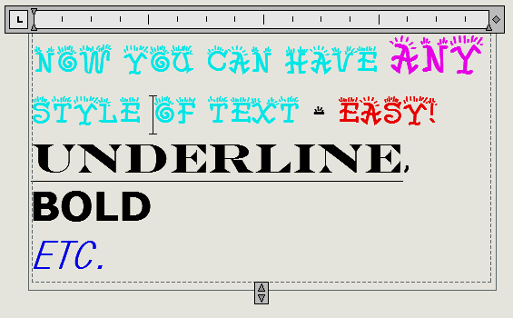

**NOTE:** AutoCAD uses two types of fonts: true-type and 'SHX' C:\Users\Yegon\Documents\Classwork 3rd sem 2011-2012\Autocad tutorials\2-6_files\shx_icon.gifvector fonts. True-type fonts are indicated by a small TT Iconsymbol beside the font name. As a rule, you will want to use the SHX fonts, as AutoCAD can draw these faster. Newer releases of AutoCAD handle true-type faster than before, but they can still slow down your display speed. Another concern when using True-type fonts is that if you are exchanging drawing files with other people, they may not have the same fonts installed on their system. This could lead to formatting problems when they open your files.

**Editing text**

The easiest way to edit the contents of your text (what you wrote) is to double click on it. Depending up your method of entering the text, a different editor will appear (Mtext or single line text).

If you want to change the shape of your Mtext box, just pick on the text, and use grips to drag the fram to the right or to the bottom.

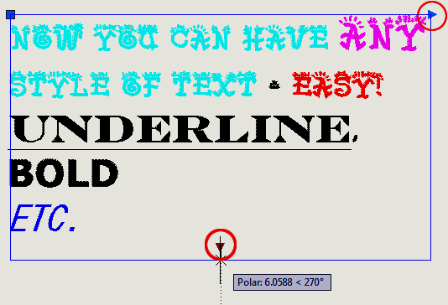

Single line text cannot be changed like this. When deciding when to use single or multiline text, think about how the text will be used, if it might be edited later, it's generally a safer bet to use Mtext.

**Arc-Aligned Text**

Recently AutoCAD added a selection of commands called "Express Tools". These are regular AutoCAD commands, but they aren't fully supported (meaning don't cry to Autodesk if they don't work). They are also sometimes installed separately from the regular AutoCAD installation, so you may not have them on your screen. But they do offer a nice option to some drawing problems. One of these Express Tools is Arc-Aligned Text. Just like the name suggests, you can place text along an arc.

Draw an arc and start the command as shown above. As prompted, select the arc, and this dialog box will appear:

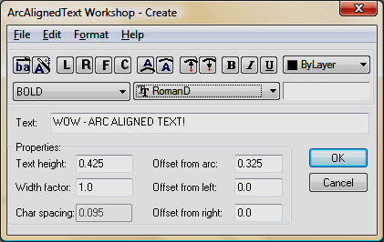

As you can see, there are quite a few options. Use the default settings and you should have text that looks something like this:

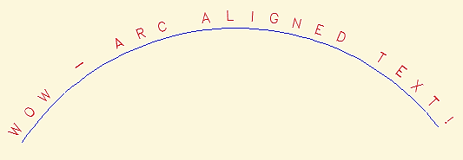

You can also erase the arc and the text will remain. This isn't a command that you will use a lot, but it is comforting to know that it's there.

**Polylines**

A polyline is an object in AutoCAD that consists of one or more line (or arc) segments. A rectangle is an example of a polyline that you are already familiar with. As you've seen, it is one object that can be modified and worked with easier than four separate lines.

Polylines are created using the **POLYLINE** command, invoked by typing **PL** at the command line. To draw a simple polyline, draw it as though you are using the line command. The only difference is that it is ***one*** object instead of many.

Polylines have some unique qualities that make them very useful:

1. They can have width (constant or varying)
2. They can consist of arcs and lines.
3. They can be edited
4. They can be joined together.
5. They can be exploded into individual segments

|  |  |  |  |  |
| --- | --- | --- | --- | --- |
| **Command** | **Keystroke** | **Icon** | **Location** | **Result** |
| Polyline | **Pline / PL** | Polyline Icon | Home > Draw > Polyline | Creates a polyline of arcs and/or lines. |
| Polyline Edit | **Pedit / PE** | Polyline Edit Icon | Home > Modify > Polyline Edit | Edits polyline objects |
| Explode | Explode / Exp | Explode Icon | Home > Modify > Explode | Separates objects into individual components. |

When you start the command, you will notice that there are several options available:

Command: PL PLINE  
Specify start point:  
Current line-width is 0.0000  
Specify next point or [Arc/Close/Halfwidth/Length/Undo/Width]:

Remember that any time you want to choose an option, you type in the **C**apitol letter of that option.

One important tool is the **Close** option. This truly closes a polyline, which is different that just having two ends meeting at the same point - it's like welding the ends together. A closed polyline is required for extruding into 3-D space and other modifications. If you use the **C** option while drawing to complete your polyline, it will automatically be closed.

The **Spline** option allows you to draw a shape of lines using arcs and/or straight lines and then change them into one flowing curve. (Spline is also a separate command on its own.)

Also by changing the width of a polyline, you can get some different looks to your lines.

Look at the examples below and then practice drawing polylines and try some of the options available.

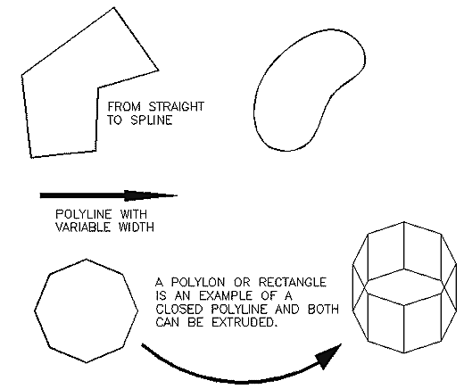

***Exercise***

Below is a sample drawing you can reproduce using a polyline (it could represent a slot to be cut out with a CNC router. First, think about how you would draw it using lines, arcs and circles.

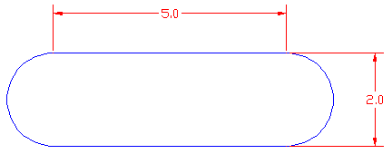

Here's how you draw it using one polyline:

Command: PL PLINE  
Specify start point: <pick a point>  
Current line-width is 0.0000  
Specify next point or [Arc/Halfwidth/Length/Undo/Width]: 5  
Specify next point or [Arc/Close/Halfwidth/Length/Undo/Width]: A  
Specify endpoint of arc or  
[Angle/CEnter/CLose/Direction/Halfwidth/Line/Radius/Second pt/Undo/Width]: 2  
Specify endpoint of arc or  
[Angle/CEnter/CLose/Direction/Halfwidth/Line/Radius/Second pt/Undo/Width]: L  
Specify next point or [Arc/Close/Halfwidth/Length/Undo/Width]: 5  
Specify next point or [Arc/Close/Halfwidth/Length/Undo/Width]: A  
Specify endpoint of arc or  
[Angle/CEnter/CLose/Direction/Halfwidth/Line/Radius/Second pt/Undo/Width]: CL

Remember [DDE](http://www.we-r-here.com/cad/tutorials/level_1/1-9.htm)? Start by entering your first point, then (with Ortho or Polar on) move your cursor to the right and type 5 <ENTER> then A <ENTER> for arc and move your cursor up and type 2 <ENTER> then type L <ENTER> (to go back to straight lines) and more your cursor to the left and type 5 <ENTER> then back to arc (A <ENTER>) and then type CL to close the polyline. Wow! That was easy!

To edit a polyline, use the **PEDIT** command or type **PE** at the command line.

**Command: PE PEDIT Select polyline or [Multiple]:  
Enter an option [Close/Join/Width/Edit vertex/Fit/Spline/Decurve/Ltype  
gen/Undo]:**

One of the most common editing tools is the **Join** (J) option. Use this to combine two or more polylines and their endpoints.

Use the LINE command to draw a line from 0,0 to 5,5. Now use the line command to draw a line from 5,5 to 8,5. This will leave you with 2 line objects that share a common point (5,5). Start the PEDIT command (PE) and select one of the lines. AutoCAD will ask you if you want to turn it into one, select Y <enter>.

Command: PE PEDIT Select polyline or [Multiple]:  
Object selected is not a polyline  
Do you want to turn it into one? <Y><ENTER>  
Enter an option [Close/Join/Width/Edit vertex/Fit/Spline/Decurve/Ltype gen/Undo]: J  
Select objects: <select a line> 1 found

Select objects: <select the other line>  
1 segments added to polyline

Enter an option [Close/Join/Width/Edit vertex/Fit/Spline/Decurve/Ltype  
gen/Undo]:<Enter>

Now you have one object (a polyline). This is a handy tool to use for editing.

Now the shape is complete and you can offset it, scale it, etc., as one object. In 3D, you could also extrude it (if it is closed).

Once you have a polyline, it is sometimes useful to break it into the individual segment. For example, you might want to offset segments by varying distances.. To do this, use the Explode command. It is used to separate many other AutoCAD objects as well such as blocks.

Polylines are useful - try to use them whenever possible. Sometimes you can draw the outside walls of a building, offset the polyline for the wall thickness, then explode both of them for more versatility.

**Revcloud(Revision Cloud)**

Another version of the Polyline command is the Revcloud (Revision Cloud) command. This is something you don't want to see on your drawings when the boss reviews your work. A Revcloud is used to highlight problems or errors in a drawing.

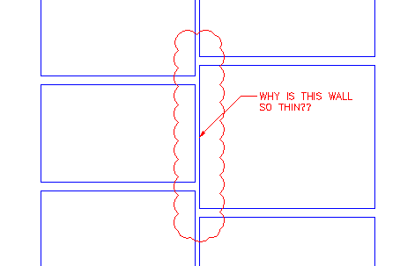

You might also want to create a Revcloud to highlight a question you have with your own work.

To create a revcloud, start the command. Then set the arc length to about 12 for an architectural drawing, or test out different arc lengths.

Command: REVCLOUD

Minimum arc length: 96' Maximum arc length: 96' Style: Normal  
Specify start point or [Arc length/Object/Style] <Object>: A

Specify minimum length of arc <96'>: 12

Specify maximum length of arc <1'>:<ENTER>

Specify start point or [Arc length/Object/Style] <Object>:  
Guide crosshairs along cloud path... <MOVE YOUR MOUSE AND CLOSE THE REVCLOUD>  
Revision cloud finished.

You might have ended up with something like this:

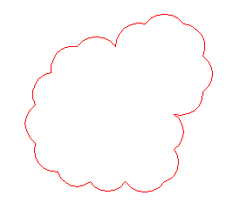

One thing with revclouds is that it can be hard to define a specific area clearly. Therefore, you have another option for creating accurate, clean revclouds like the one in the first example. Start by drawing a rectangle over the area you want to highlight, then start the Revcloud command and choose the Object option. Select the rectangle and press enter to end the command. This will work on most AutoCAD objects.

**Parametric Constraints**

Parametric constraints allow you to force an object to behave the way you want it to. If you need a line to remain vertical at all times, you can set a constraint on it to do just that. Need 2 circles to remain the same diameter? How about a circle for a bolt that must stay 1/2" diameter? No problem with constraints. These are just some examples that will make it easier to control your drawing.

Constraints can be divided into two groups and are on the Parametric Tool Panel:

|  |  |  |
| --- | --- | --- |
| **Geometric Constraints** | Geometric Constraints | Constrains a object based on geometric properties : vertical, horizontal, etc |
| **Dimensional Constraints** | Dimensional Constrinats | Constrains an object based on a set length or radius. |

This tutorial is not going to explain each one, but jut show you how they're used and then you can explore the others and learn how they work. This may not be something that you use in everyday drafting, but it can very useful at times.

**Geometric Constraints**

Let's start with an easy one. Draw 2 random lines without having Ortho on.

Click on the Parallel Constraint icon Parallel Constraintand then select one line and then the other. The second line should now be parallel with the first.

**Command: \_GeomConstraint  
Enter constraint type   
[Horizontal/Vertical/Perpendicular/PArallel/Tangent/SMooth/Coincident/CONcentric  
/COLlinear/Symmetric/Equal/Fix] <Symmetric>:\_Parallel  
Select first object: <Select first line>  
Select second object: <Select second line>**

The angle of the first line will be the constraint put upon the second line. Now if you try moving one of the lines around, you'll find that the two will stay parallel. If you highlight one, the other becomes highlighted. You also now have constraint indicators next to the objects.

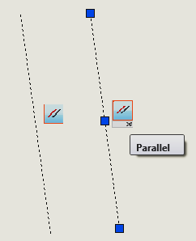

Most of the geometric Constraints work the same way. Select an object to create the constraint and then select another to match. You can only constrain 2 objects at a time, but you can use multiple constraints to constrain multiple objects. If you copy one of the constrained objects, **the constraint does not copy with it**.

Try out a bunch of the geometric constraints before moving on to dimensional constraints. Notice how the procedure is pretty much the same. See what happens when you add a new constraint to an object that already has a constraint.

**Dimensional Constraints**

Dimensional constraints are different from what you just worked with. Instead of making a line vertical (for example), you can make a line 10 units long and make it stay that way until you change it. You can more than one dimensional constraint on certain objects.

Draw a random angled line on the screen. Pick on the Aligned constraint icon. Aligned ConstraintPick two points on the line.

Notice that even if you have your Osnaps off, you can only pick the endpoints and midpoint on the line. After selecting the 2 points, you can now enter a length that you want the distance between those points to be.

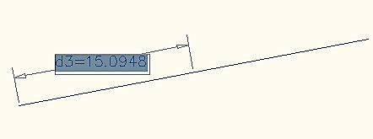

With the constraint still highlighted, enter a number. d3 in this example refers to the 3rd dimensional constraint in the drawing. If you added a constraint from end to middle, add another from end to end (or vice versa). Notice that the constraint will be double the first one. If you change one, the other will change.

**Mixing it up**

You'll notice in the geometric constraints panel, there is one for equal. This can used to make objects the same size. In this example, draw 2 different sized circles. Make one a dimensional constraint for diameter. Now use the Equals constraint Equals Constraintto make the other one the same.

Imagine using this when you are designing a part with holes to be drilled. If the part isn't finalized yet, the hole size might change. Using the Equals constraint would allow changing one and making others the equal at the same time.

This tutorial has shown you the basics of working with parametric constraints. They are simple to use, easy to delete if you don't need them any more, and they can be a great time saver. Practice with them. Go over some previous exercises using constraints.